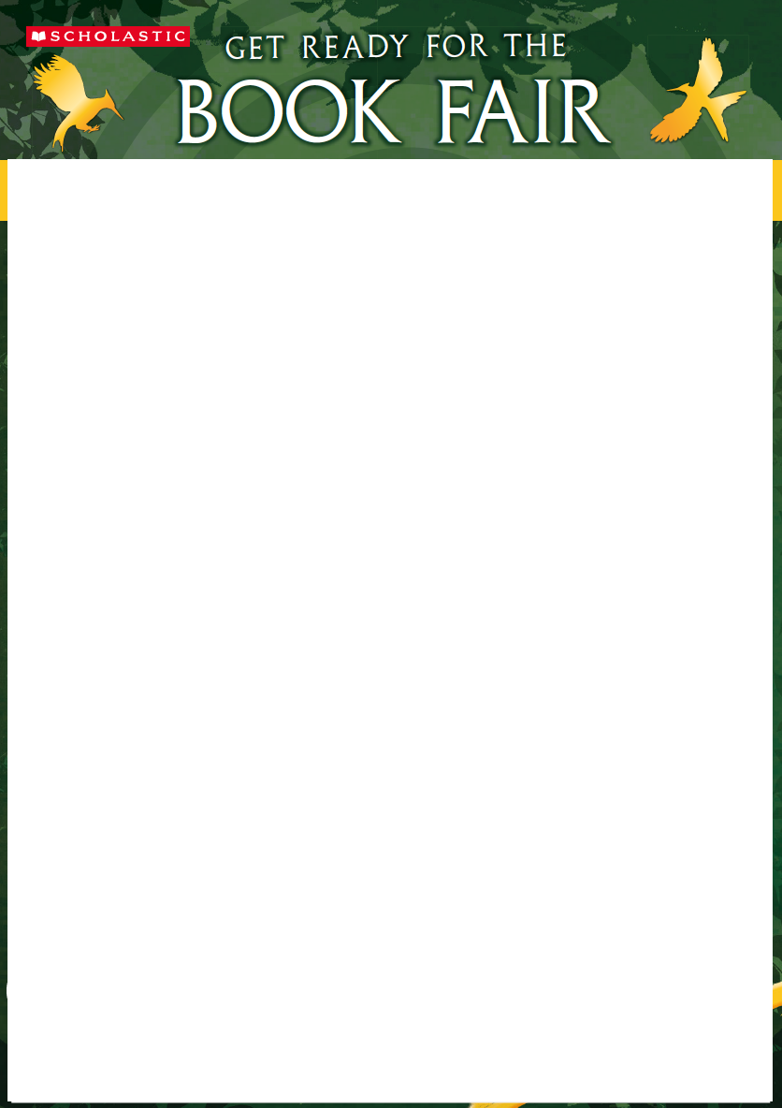

If you join your school’s Book Fair order, you will benefit from FREE P+P to your school!

After making your selection from the catalogues:

|  |  |
| --- | --- |
| 1. Pay online: **Visit bookfairs.scholastic.co.uk/pay**. Our postcode is HG5 8EB. Please have a pen ready to record your reference number. | |
| 1. After payment is made, this form should be completed and emailed to: library@king-james.n-yorks.sch.uk | |
|  | |
| Name of Payee: | School customer  I.D. number: 27601954 |
| Payment Reference  Number: | Transaction  Value: |

1. **Fill in your order details below:**

|  |  |  |  |  |
| --- | --- | --- | --- | --- |
| **Title** | **Price** | **Quantity** | | **Total** |
|  |  |  | |  |
|  |  |  | |  |
|  |  |  | |  |
|  |  |  | |  |
|  |  |  | |  |
|  |  |  | |  |
|  |  |  | |  |
|  |  |  | |  |
|  |  |  | |  |
|  |  |  | |  |
|  | **Total Order Value** | |  | |
| Student’s name: | **Form:** **AR Class:** A/B Day: **Period:** | | | |
| Parent’s name: | | | | |
| Staff name: |  | | | |
| School name: King James’s School | School postcode: HG5 8EB | | | |
|  |  | | | |
| **Final Step:** | | | | |

Please email this form to [library@king-james.n-yorks.sch.uk](mailto:library@king-james.n-yorks.sch.uk) with the subject heading – **Book Fair**.

Alternatively, this form can be printed and returned directly to Mrs Bryden or Miss Lloyd in the library by **Tuesday, 7th December 2021.**

**THANK YOU FOR YOUR ORDER**