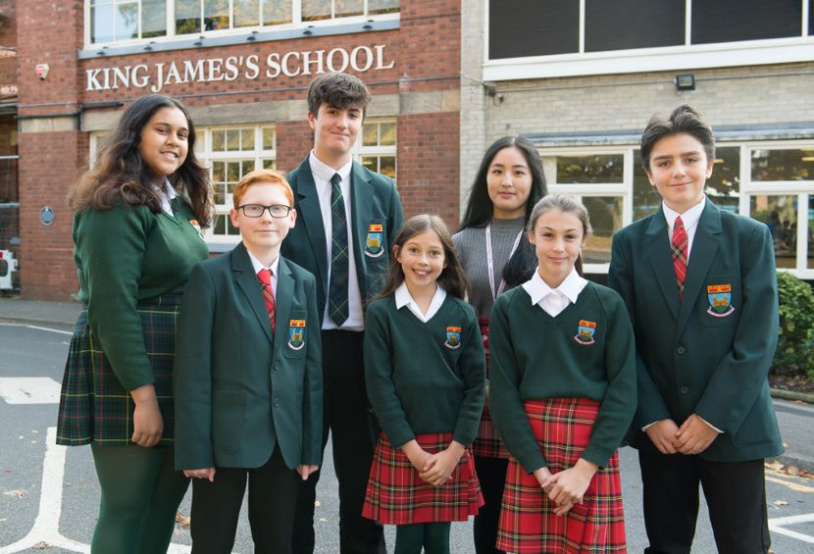

Candidate
Information

Note from the Headteacher

Thank you for your interest in working at King James’s School.

I would say at the outset that this is a very rewarding school in which to work.

Many job adverts specify what they demand from the candidate. We have plenty of skills and qualities that we are looking for but we also have a lot to offer to prospective candidates. First and foremost the students here are great to work with. It is a comprehensive school and our students reflect the full range that you would find in any area. Although some pupils need more support, most of our students come to school eager to learn and to contribute to their school community. The local community is supportive of the school, the catchment area is well defined and we have excellent relationships with parents who choose to send their children here. There is pressure for places from beyond our catchment area. Knaresborough and North Yorkshire isn’t just a great place to teach, it’s a great place to live.

The extra-curricular life of the school is rich, most staff who work here make the most of it; there really is a vibrancy here that is difficult to match. We have a committed staff (teaching and non-teaching) who go the extra mile. Almost without exception, teachers go above and beyond the core delivery of lessons to enhance the enrichment opportunities for the students.

The ethos here is one of the strengths. Even though we have a charter going back to 1616 we are a very forward facing school with an open and friendly ethos. We are highly inclusive and we have a strong reputation for delivering outstanding care and outcomes for students with SEND alongside an enviable output to top university courses from our high-performing A level students. Our A level results place us in the top 20% of providers nationally consistently, year on year.

We are demanding of our staff, teaching and associate staff. We believe that our community deserves an outstanding school and we strive to be outward facing, never resting on our laurels and always seeking further improvement. We expect students and staff to embrace challenge and to see resilience and hard work as the route to success. At the same time we have a very strong commitment to the development and training of all staff, teaching and non-teaching. The opportunities for your personal development are rich in this school.

Thank you for considering King James’s School.
Carl Sugden
Headteacher

Teacher of English
September 2022 start
Fixed Term to August 2023
0.4 fte
NQT, MPS or UPS

We are seeking an enthusiastic, imaginative and energetic Teacher of English to join our highly successful and supportive team continually performing amongst the top 20% of schools nationally.

King James’s School is a large 11-18 comprehensive school proud to offer a diverse and rich curriculum and is committed to high quality professional development and career opportunities for all staff. We run a School Direct secondary programme to train the next generation of teachers.

You will be joining a highly community orientated, inspirational and ambitious school. We are seeking an outstanding candidate to support our educational aims who has the vision, drive and interpersonal skills to motivate our students. You will benefit from strong leadership, effective support by colleagues and being part of an ethos that achieves the best possible outcomes for our students.

The English Department is high performing and teaches through to Key Stage 5. At GCSE we use AQA and for A level we use AQA (Language), Media (OCR) and Edexcel (Literature)

You will be teaching Key Stage Three English and have the capacity to teach some Key Stage Three Humanities. You will also take a key role in English Intervention work.

The school is committed to safeguarding and promoting the welfare of young people and expects all members of staff to share this commitment. This position is subject to an enhanced DBS check and approved references.

Full post details and an application form are available via our website. Completed applications must be submitted via email to recruitment@king-james.n-yorks.sch.uk and received by Tuesday 12th July by 08.00am.
Please note that CVs will not be accepted.
Interviews to be held Monday 18th July 2022
Information on the English Department

Dear prospective applicant,

I am delighted to be Head of Faculty for a highly successful English Department which over recent years has been progressing from strength to strength. In 2019 89% of our student achieved 9-4 and we were delighted that our Grade 9s was significantly above the national average for the third year in a row; the department’s results have gone from strength to strength in recent years and the entire team are very proud of what our students have achieved. Sustained improvement within the department has been brought about by detailed and effective schemes of work at Key Stages 3 and 4, along with consistent development in the teaching and learning of English for all pupils of all abilities. There is still work to do in improving our outcomes at GCSE and of course ensuring that we deliver a recovery curriculum that supports those students who have gaps in their learning as a result of the pandemic; this is a challenge the department are excited by and we have enjoyed the opportunity to refresh our teaching and make sure all students are fully prepared for their exams.

The capacity to have such a sharp focus on effective teaching and learning is made possible by the tremendous students at King James’s. It is a comprehensive school with an intake of pupils from all backgrounds but by and large our classes are filled with well-motivated students willing to improve their English learning and contribute to their school community.

I am fortunate to lead a team of staff who have a wide range of backgrounds, expertise and experiences. We work as an innovative team - sharing ideas which we then embed into our practice. We are fortunate in the structure of our English responsibilities, having members of staff who hold TLRs for A level English Language, A Level Media and A level Literature as well as a Second in Department with responsibility for Key Stage 3. We also have a lead practitioner who plays an integral role in driving teaching and learning within the department. Through a recent curriculum change at all key stages, the department have been excited by the opportunity to innovate. Research based teaching and learning is at the heart of everything we do in the English department.

You will be supported in your teaching by detailed schemes of work and resources developed and shared across the department. We hope to appoint someone willing to teach across all key stages; key stage 5 leaders are happy to provide additional guidance to those new to teaching A-level literature, language or media.

We are open to applicants of all levels of experience. Should we appoint an NQT, the school offer an extensive induction programme and you would have a mentor within the department to guide you through your first year of teaching. As well as thorough schemes of work, shared resources and systems to support classroom management, you will have your own classroom, Smartboard and Ipad. CPD is a vital part of our approach to teaching and learning at King James’s School. We use department meeting and development time to ensure we reflect on our lessons and share good practice as well as exploring the latest innovations in education; we believe that English lessons should be exciting and engaging and we aim to be at the cutting edge in the classroom.

Finally, I would say that if you decide to apply I appreciate your investment of time and whatever the outcome, I wish you well in the future.

Yours sincerely,
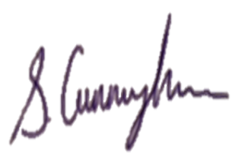
Sophie Cunningham
Head of English Faculty
How to Apply

Please complete the King James’s School teaching application form.

Please use the section “Experience & Qualities relevant to the Post” on the application form to demonstrate how you can meet the criteria given in the advert.

Please note CVs will not be accepted. Please do not enclose a covering letter as this will not form part of your application.

We are committed to safeguarding and promoting the welfare of young people and expect all members of staff to share this commitment.

An Enhanced DBS disclosure is required for this post through North Yorkshire County Council. This will be arranged for the successful applicant.

Your completed application form must be submitted via email to
recruitment@king-james.n-yorks.sch.uk and be received by Tuesday 12th July by 08.00am.

Interviews to be held Monday 18th July 2022

Thank you for your interest in this post. If you have not heard from us within 21 days of the closing date, please assume your application has been unsuccessful and, in that event, may we wish you well in your search for a suitable position.

ED5880
ED6037

King james’s school, knaresborough

JOB DESCRIPTION
All job descriptions will be reviewed annually & set in the context of the school’s aims & current development plan

TEACHER of ENGLISH

 | To be accountable for students’ attainment and achievement. To ensure all students make progress by promoting, monitoring and supporting the overall learning and personal development of students. To uphold the aims, policies, procedures and ethos of the school.
 | Line Manager: |  | Head of Department
 | Responsible to: |  | - Performance Manager  - Head of Department  - Head of Year
 | Salary Grade : |  | Main Pay Scale  Upper Pay Scale
 | Full Time/FTE : |  | Part time (0.4fte)
Professional Responsibilities
all TEACHING STAFF
1. |  | Work within the School Teachers Pay and Conditions Document.
2. |  | Promote the school’s stated ethos
3. |  | Contribute to and implement the annual School Improvement Plan and agreed policies
4. |  | Teach as directed throughout the school subject to appropriate training
5. |  | Monitor, expect and improve progress in pupil learning
6. |  | Participate in the pastoral management of the school as requested
7. |  | Take part in performance management procedures outlined in an agreed school policy
8. |  | Take responsibility for their own professional development
Specific Responsibilities
ALL TEACHING STAFF
1. |  | Plan and deliver lessons using a range of strategies to meet pupils' individual learning needs.
2. |  | Have a thorough knowledge and understanding of their subject, its teaching and place in the National Curriculum and that of the school
3. |  | Set and mark homework according to school and department policies
4. |  | Mark, assess, record and report on pupils’ achievements, setting appropriate targets for improvement
5. |  | Meet deadlines for reporting, marking, submission of assessment data, coursework, marks and forecast grades.
6. |  | Prepare pupils for examinations, taking part in standardising and moderating activities required by departments and examination boards
7. |  | Contribute to the development of schemes of work, school and department policies as appropriate
8. |  | Attend and contribute to appropriate meetings and professional development activities
9. |  | Contribute to the process of department self-evaluation and improvement planning.
10. |  | Undertake whatever other duties might reasonably be requested by the Head or Head of Department.
Specific Responsibilities
FORM TUTORS
1. |  | Take responsibility for day to day discipline routines and attendance in the form group
2. |  | Review and discuss pupils’ work and welfare, setting targets as necessary
3. |  | Promote good behaviour and positive attitudes at all times
4. |  | Support form, year and school activities as appropriate
PERSON SPECIFICATION

TEACHER OF ENGLISH

CRITERIA | ESSENTIAL | DESIRABLE | ASSESSMENT
Qualifications & Training
- Qualified Teacher status |  |  | 2 and 5
- Good Honours degree in related subject |  |  | 2 and 5
Experience

- Teaching experience at key stage 3-4 |  |  | 2 , 4 and 5
- Teaching experience at Key stage 5
Skills & Knowledge

- Able to communicate effectively, orally and in writing. |  |  | 2 and 4
- Able to demonstrate effective planning and teaching skills |  |  | 2 and 4
- Able to present confidently to a large group of students |  |  | 2 and 4
- Able to work with others to achieve common goals |  |  | 2 and 4
- Able to use / analyse assessment data systems to raise standards |  |  | 2 and 4
- Able to provide clear direction and to inspire, motivate and enthuse others |  |  | 2 and 4
- Confident in own ability to be effective and to take on challenges |  |  | 2 and 4
- Good ICT skills (in Microsoft Word/Excel) |  |  | 2 and 4

Skills & Knowledge (continued)
- Able to form good working relationships with all staff and students |  |  | 2 and 4
- Effective behaviour management |  |  | 2 and 4
- Able to support staff and students in maintaining high standards |  |  | 2 and 4
- Up to date awareness of the National Curriculum and specifically within their individual specialism |  |  | 2 and 4
- Efficient and effective administrative, organisational and personal management skills |  |  | 2 and 4
Personal attributes

- Able to motivate others and to adopt a positive approach to education |  |  | 2 and 4
- Energy , enthusiasm and perseverance |  |  | 2 and 4
- Reliability and integrity |  |  | 2 and 4
- Good interpersonal skills |  |  | 2 and 4
- Positive commitment to individual personal development |  |  | 2 and 4
- Capacity to work hard, under pressure, to meet deadlines |  |  | 2 and 4
- Adaptable and amenable with respect to working practices |  |  | 2 and 4
- Ability to work independently and be a team player |  |  | 2 and 4
Equal Opportunities
- Understanding of equal opportunities issues and an ability to demonstrate strategies to challenge discrimination and prejudice  - A commitment to inclusive education |  |  | 4 and 5
Health & Safety
- An understanding of health & safety issues

Assessment: | 1. Test prior to shortlisting (i.e. all applicants) | 2. | From application form
 | 3. Test after shortlisting | 4. | Probing at interview
 | 5. Documentary Evidence | 6. | OTHER (please specify)

