
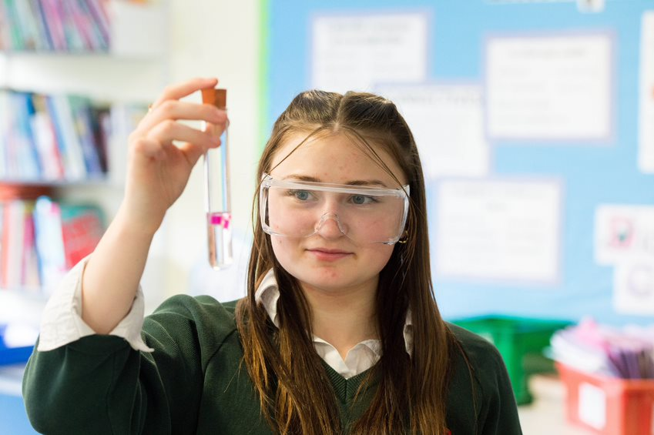


Candidate
Information

Employee Benefits


Financial Benefits

We are delighted that we are able to provide you with access to a large range of employee benefits at King James’s School.
Access to contributory pension schemes:
Local Government Pension Scheme (18% employer contribution).
Salary sacrifice schemes (e.g. cycle to work, technology and car schemes).
Discount vouchers for the high street, entertainment and supermarket shopping through Vivup.
Subsidised onsite catering facilities.


Well-being support

Health Assured Employee Assistance Programme:
Free, confidential 24/7 support and counselling.
Flexible working options and well-being initiatives.


Leave and Perks

Generous annual leave starting at 28 days (non-teaching staff), rising to 34 days plus bank holidays with service.
Free ample onsite parking.
Membership discounts at leisure centres.


Community and Additional Opportunities
Collaborative and supportive staff culture.
Lunch duty opportunities:
Hourly pay of £12.65 plus a free meal.

Some of these offers are subject to conditions and may change. See provider for full details.

Note from the Headteacher

Thank you for your interest in working at King James’s School.

I would say at the outset that this is a very rewarding school in which to work.

At King James’s School, our core values—Ready, Respectful, and Engaged—are at the heart of everything we do, shaping the attitudes and behaviours of our students and staff alike. Guided by our vision “To set no limits on what we can achieve,” we foster a culture of high aspiration and continuous growth. As a school grounded in unconditional positive regard, we believe that strong, respectful relationships form the foundation of effective learning and personal development. Our relationship-based approach ensures every student feels valued, supported, and empowered to thrive, while our staff are committed to nurturing an inclusive and inspiring environment where everyone can succeed.

We have plenty of skills and qualities that we consider important, but we also have a lot to offer to prospective candidates. First and foremost, the students here are great to work with. It is a comprehensive school and our students reflect the full range that you would find in any area, but the vast majority are well-motivated students willing to learn and to contribute to their school community. The local community is very supportive of the school; the catchment area is well defined and we have excellent relationships with the local parents who choose to send their children here. We fill up each year with pressure for places from beyond our catchment area. Knaresborough and North Yorkshire is not just a great place to teach, it is a great place to live.

The extra-curricular life of the school is rich. Most staff who work here involve themselves in it; there really is a vibrancy here that is difficult to match. We have a committed staff (teaching and non-teaching) who go the extra mile. Almost without exception, teachers go above and beyond the core delivery of lessons to enhance the enrichment opportunities for the students.

The ethos here is one of the strengths. Even though we have a charter going back to 1616 we are a very forward-facing school with an open and friendly ethos. We are highly inclusive and we have a strong reputation for delivering outstanding care and outcomes for students with SEND, alongside an enviable output to top university courses from our high-performing A level students. Our A level results place us in the top 20% of providers nationally consistently, year on year.

We are demanding of our staff, teaching and associate staff. We believe that our community deserves an outstanding school and we strive to be outward facing, never resting on our laurels and always seeking further improvement. We expect students and staff to embrace challenge and to see resilience and hard work as the route to success. At the same time, we have a very strong commitment to the development and training of all staff, teaching and non-teaching. This is a school in which the opportunities for your personal development are rich.

We believe in collaborative working with other schools. We are proud of the relationships that we have fostered, including taking the lead role within the White Rose Alliance for School Direct. We are also federated with another local school, Boroughbridge High, for whom we provide 6th form provision and some non-teaching support.

Thank you for considering King James’s School and we look forward to receiving your application.
Miriam Oakley
Headteacher



Advanced Teaching Assistant
Term Time Only (including Training Days)
31.25 hours per week.
£19,028 to £19,954 (actual)




King James’s School is offering an exciting and rewarding opportunity to work as an Advanced Teaching Assistant as part of our highly effective learning support team.

Under the leadership and support of our SENCo you will be working with students with a range of special educational needs. Part of this role will be supporting and delivering small group and 1:1 targeted intervention programmes for students with a range of Special Educational Needs. For example, those with cognition and learning needs, communication and interaction needs and social, emotional and mental health (SEMH) needs. The successful candidate will work alongside the SENCo, Assistant SENCo and other members of the SEND and pastoral team to support a specific year group.
Specific ATA roles and responsibilities will be agreed upon appointment.

This is a Term Time Only (plus Training Days) contract.

We are seeking an outstanding candidate to support our educational aims who has the vision, drive and interpersonal skills to motivate our students. You will benefit from strong leadership, effective support by colleagues and being part of an ethos that achieves the best possible outcomes for our students.

The school is committed to safeguarding and promoting the welfare of young people and expects all members of staff to share this commitment. An Enhanced DBS disclosure is required for this post.

For an application form please visit our school website.
Completed applications must be submitted via email to:
recruitment@king-james.co.uk by 8am Monday 11th May 2026

Please note that CVs will not be accepted.

Information on the Learning Support Department

The Learning Support Department lies at the heart of teaching and learning within King James’s School. The department aims to create a safe and inclusive learning environment where all students gain a sense of achievement and are enabled to reach their full potential during their time at King James’s School, both academically and pastorally.

The department has a long-standing policy of enabling students to access a broad and balanced academic and pastoral curriculum. Students are supported to become part of the wider King James’s community and participate in a full range of sports, clubs, extra-curricular activities, charity events and residential trips.

The SENCo is supported by a non-teaching Assistant SENCO. Learning Support teaching staff deliver lessons to the Student Support Group - a specialist part of our provision for those students with the highest level of learning need. A Senior Advanced Teaching Assistant is attached to KS4, and at KS3, an Advanced Teaching Assistant is attached to each year group. A Senior Teaching Assistant specialising in ASD works across all key stages. They act as a key liaison between the SENCO, teaching staff, students, and parents. The department is further staffed by Teaching Assistants who work primarily within a year group and teams or within core subject departments.

The Learning Support Department offers a comprehensive range of support, which compliments the wider support network within the school, enabling students’ access to a wide range and varied curriculum. The support offered varies from in-class support, small group work and 1:1 mentoring, through to targeted interventions and personalised timetables. Some students are part of our Student Support Group which provides a tailored learning package for our most vulnerable learners. Every student is individually assessed, with the level of support then tailored to the needs of that individual. Once at King James’s School, student progress is regularly monitored and assessed. This information is then used to inform further support requirements.

Over the years we have established strong links with our feeder primary schools so that we can make full use of the information provided by Year 6 teachers. Our team runs a full programme of transition events and activities both at King James’s and at our feeder primaries. We are proud of our track record of successful transition for our students including those with very complex needs.

How to Apply

Please complete the King James’s School non-teaching application form.

Please use the section “Experience & Qualities relevant to the Post” on the application form to demonstrate how you can meet the criteria given in the advert.

Please note CVs will not be accepted. Please do not enclose a covering letter as this will not form part of your application.

We are committed to safeguarding and promoting the welfare of young people and expect all members of staff to share this commitment.

An Enhanced DBS disclosure is required for this post through North Yorkshire County Council. This will be arranged for the successful applicant.

Your completed application form must be submitted via email to
recruitment@king-james.co.uk and be received by 8am Monday 11th May 2026

Thank you for your interest in this post. If you have not heard from us within 21 days of the closing date, please assume your application has been unsuccessful. In that event, may we wish you well in our search for a suitable position.
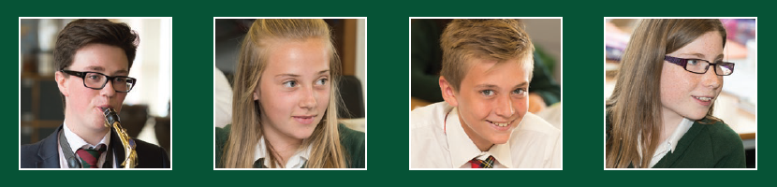
King james’s schoo james’s school, knaresborough

JOB DESCRIPTION
All job descriptions will be reviewed annually & set in the context of the school’s aims & current development plan

Advanced teaching assistant

 | Line Manager: |  | SENCo
 | Responsible to: |  | - Head Teacher  - Senior Advanced Teaching Assistant  - SENCO
 | Salary Grade : |  | Grade E
 | Full Time/Part Time : |  | Hours depending on individual contract
 | Hours: |  | Hours depending on individual contract
 | Full Year / Term Time Only: |  | Term Time Only (incl. Training Days)
 | Date of issue: |  | April 2025
Professional Responsibilities
all ASSOCIATE STAFF
1. |  | To work within the North Yorkshire County Council’s Conditions of Service
2. |  | To support the aims, policies, procedures and ethos of the school
3. |  | To participate in the school’s agreed Performance Management procedures
4. |  | Help safeguard the welfare of children in the school and ensure services are delivered with regard to equalities
5. |  | Work safely and co-operate with health and safety procedures
6. |  | Attend school meetings as appropriate within designated working hours
7. |  | Undertake appropriate staff training and development activities
8. |  | Undertake whatever duties might be reasonably requested by the Head or Line Manager

Context Statement
- This school is committed to safeguarding and promoting the welfare of our pupils and young people. We have a robust Child Protection Policy and all staff will receive training relevant to their role at induction and throughout employment at the School. We expect all staff and volunteers to share this commitment. This post is subject to a satisfactory enhanced Disclosure and Barring Service criminal records check for work with children.
- The school is committed to supporting the needs of all children so that they can fulfil their full potential. This includes supporting children with their Social, Emotional and Mental Health (SEMH) needs and wellbeing. We expect all staff and volunteers to share this commitment.
- The school supports access to the curriculum for all children as part of NYC’s commitment to inclusive education
- The school is inclusive to all children and will support their individual needs. In line with the school’s commitment to ensure access to education for all children, the school may require staff to support children/s medical needs (loco parentis) in line with a healthcare plan. Where required, additional training will be provided as appropriate, and an additional allowance may be an entitlement whilst undertaking such duties.
- All school employees are responsible for contributing to a learning environment that is innovative, engaging, happy and fulfilling for all pupils, and for ensuring all pupils’ safety and welfare
- Advanced Teaching Assistants are based in schools and educational settings, responsible for assisting and contributing to the planning, delivery and evaluation of the learning process. The postholder will typically work with groups of learners, under the supervision of a qualified teacher. They can be responsible for working within a specific area (e.g. pastoral, behaviour, SEN), depending on the needs of the educational establishment.
- Can be responsible for working within a specific work area, e.g. Pastoral, Behaviour or SEN

Job purpose | To work, under the direction of the class teacher and other appropriate staff, in assisting in and contributing to the planning, delivery and evaluation of the learning process. The post holder will work in classes, or other appropriate locations with access to support and guidance, supervising groups and /or individual pupils.  To assist in the induction and development of classroom support staff as required.  To provide support to pupils including promoting pupils’ independence, self-esteem, and social inclusion
Supporting Learning and Development: | - Assist in the planning and evaluation of learning and SEMH activities with the teacher. Deliver learning activities for individuals and groups of pupils under the professional direction and supervision of a qualified teacher, differentiating and adapting learning programmes to support the needs of allocated pupils  - Support pupils with special educational needs through assisting with the delivery of specific learning programmes in line with the individual education plan (IEP) targets and to IEP reviews, for example through working one to one or with a small group on phonics catch-up activities.  - Support the facilitation of pupils’ access to educational provision as indicated by their Education, Health and Care Plan, where appropriately delegated  - With the class/subject teacher, plan and deliver small group interventions, with clear objectives and appropriate learning outcomes  - Monitor and record pupil responses and learning achievements and give appropriate feedback to teachers towards the overall assessment of pupil progress and attainment made by the teacher and other professionals  - Interact with pupils in ways that support the development of their ability to think and learn, including the use of careful questioning  - Support and assist in the development and implementation of appropriate behaviour management strategies in accordance with whole school policy  - Take account of the effects of different parenting approaches, backgrounds and routines, and be involved in home school liaison, as directed by the class/subject teacher  - Support pupils in their social and emotional wellbeing, in implementing related programmes, including those with additional SEND and wellbeing needs, physical needs and medical needs with training, encouraging and modelling positive behaviour in line with school policy.  - Escort and supervise pupils on educational visits and out of schools activities under the supervision of a teacher  - Undertake allocated supervision during breaktimes as required  - Contribute to effective assessment and planning by supporting the monitoring, recording and reporting of pupil performance and progress as appropriate to the level of the role, for example through feeding back to the class teacher about progress that the pupil has made during a learning activity.  - Prepare for lessons appropriately including reading of materials shared prior.
Communication: | - Establish rapport and respectful, trusting relationships and communicate effectively with pupils, their families and carers, and other agencies / professionals  - Initiate appropriate and effective communication with the class teacher, and other professionals, forging and sustaining relationships across agencies  - Be clear about the level of instruction, procedures and guidance that this role works within
Sharing Information: | - Assess, record and report on pupils’ attainment and progress within assessment and reporting processes  - Participate in meetings with other staff, external professionals and parents regarding pupils, in a support capacity to the teacher, who will normally lead on such matters  - Assist in the induction and development of classroom support staff, cascading information and good practice  - Pay due regard to professional boundaries, maintaining appropriate levels of confidentiality  - Participate in staff meetings  - Share information confidentially about pupils with teachers and other professionals as required
Safeguarding and Promoting the Welfare of Children and Young People: | - Carry out tasks associated with pupil’s personal hygiene and welfare, including personal intimate care, physical and medical needs, whilst encouraging independence  - Be responsible for promoting and safeguarding the welfare and wellbeing of pupils in line with policy and legislation, raising concerns as appropriate
Administration / Other: | - Assist the teacher and work as directed in preparation of the classroom and resources for planned work to take place  - Undertake routine clerical duties as required  - Support the use of ICT and adhere to relevant policies  - Supervise and provide access arrangement for pupils sitting internal and external examinations and tests, ensuring that examinations comply with Examination Board Regulations  - Participate in appraisal, training and other performance management activities

Appropriate duties | Duties that are not appropriate for this role and should be allocated to another role which includes these within their responsibility
Supervising groups of pupils & individual pupils. | Be required to take full responsibility for a whole class for a full lesson.
Working under the direction of the class teacher and other appropriate staff. | Delivering learning activities to individual pupils and small groups, except in support of and under direction of the class teacher, SENCo or Assistant SENCo.
Assisting in & contributing to the planning, delivery & evaluation of the learning process. | Be providing cover for teaching absences.
Assisting in the induction & development of classroom support staff. | Be responsible for managing other support staff
Participating in relevant training as appropriate | Specific allocation to support individual pupils’ SEMH or wellbeing needs – for example designated regular support to pupils who are dysregulated
Support all pupils’ wellbeing in the classroom setting

Person specification:
Essential | Desirable
Knowledge and Experience  - On entry, good understanding of child/ young people’s development and learning processes  - Understanding of guidance and requirements around safeguarding children and young people  - Understanding of individual children and young people’s needs  - An understanding that children/Young people have differing needs and knowledge of inclusive practice  - Appropriate experience working with children in an education setting | - Knowledge of Behaviour Management techniques  - Knowledge of Child Protection policies and procedures  - Knowledge of Health and Safety legislation  - Experience in other relevant skills e.g. art/music/sport  - Experience of delivering evidence based interventions that accelerate learning
Occupational Skills
- Good written and verbal communication skills: able to communicate effectively and clearly and build relationships with a range of staff, children, young people, their families and carers
- Behaviour management
- Good reading, writing and numeracy skills
- Demonstrable ICT skills and the ability to use ICT as part of the learning process
- Ability to understand of roles and responsibilities within the classroom and whole school context, and to work effectively as part of a whole school team

Behaviours  - Demonstrable interpersonal skills  - Ability to work successfully in a team  - Able to exercise judgement  - Confidentiality  - Flexibility | - Creativity
Professional Qualifications  - Relevant NVQ Level 3 or equivalent (minimum English and maths skills at level 2). | - Appropriate first aid training (Dependent on the school’s needs - insert as appropriate)
Other Requirements
- To be committed to the school's policies and ethos
- To be committed to Continuing Professional Development
- Motivation to work with children and young people
- Ability to form and maintain appropriate relationships and personal boundaries with children and young people
- Emotional resilience in working with challenging behaviours and attitudes
- Ability to use authority and maintaining discipline
- An empathy for equality and diversity

Assessment: | 1. Test prior to shortlisting (i.e. all applicants) | 2. From application form
 | 3. Test after shortlisting | 4. Probing at interview
 | 5. Documentary Evidence | 6. OTHER (please specify)

